Cover page
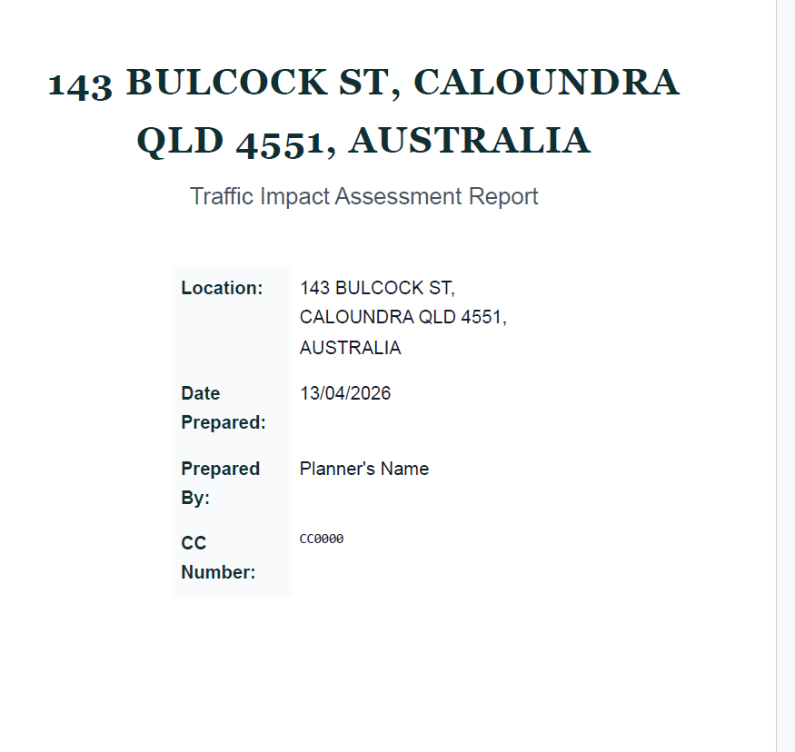

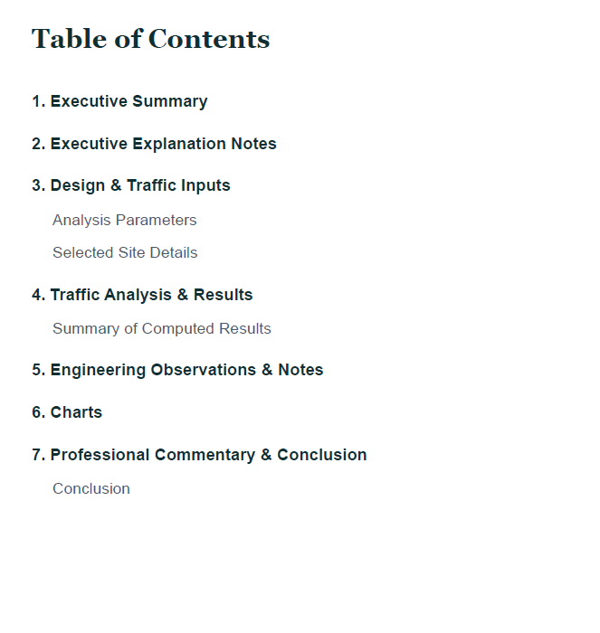

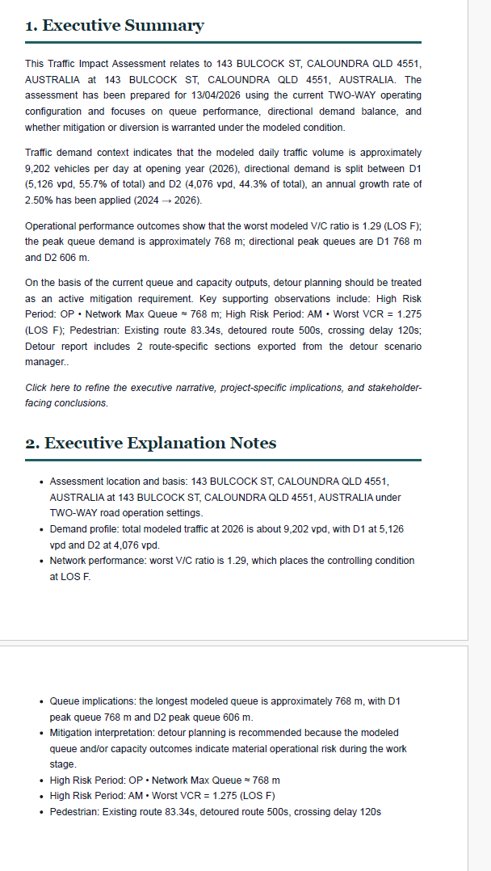
3. Design & Traffic Inputs
Analysis Parameters
Selected Site Details
Make rows and column of tables editable (add or remove option)

4. Traffic Analysis & Results
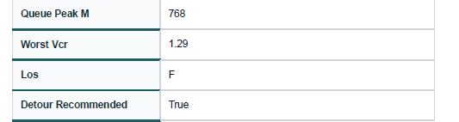
add a column to the right, that describes when peak 768 occurs, when worst vcr is seen and LOS.
Move this table, from analysis parameters to just below “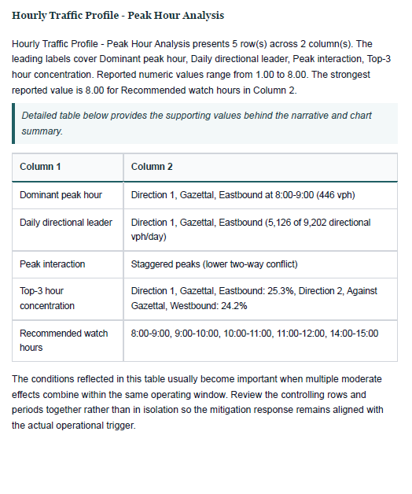
Figure 1: Move below chart just after this
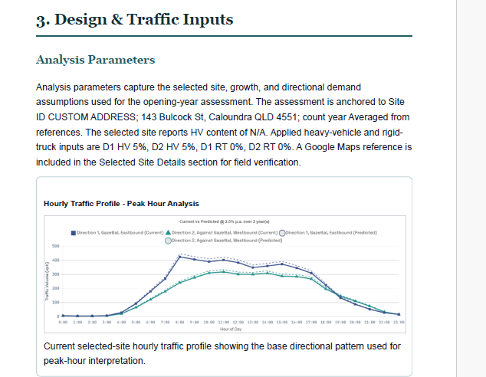
Figure 2: chart TO BE MOVED
VCR Hourly chart is showing one direction VCR only, show both directions.

Detour Analysis
A bit more details needs to be added.
Detour Route 1:
1. VPD Calculated table
2. Detour Road Directional Capacity Summary
3. Detour Road Capacity Summary
4. Existing Road Status After Diversion
5. Estimated Delay - Detour route
6. Pedestrian Detour Impact – Delay calculation
Detour Route 2:
1. VPD Calculated table
2. Detour Road Directional Capacity Summary
3. Detour Road Capacity Summary
4. Existing Road Status After Diversion
5. Estimated Delay - Detour route
6. Pedestrian Detour Impact – Delay calculation

Engineering Observations & Notes
Make it more detailed
6. Charts
Bring back all the charts here
7. Professional Commentary & Conclusion

